SMART SOLUTION FOR RAILWAYS

TEAM ID:PNT2022TMID35794

SPRINT-1: SIGN-UP & LOGIN:

MIT APP INVENTOR:

BACK-END SCREENSHOTS:

SCREEN-1:(LOGIN)

STORING DETAILS IN FIREBASE DB:
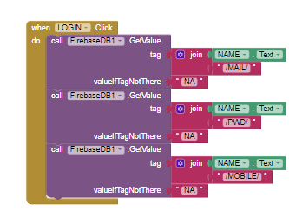

RETRIEVING DETAILS FROM FIREBASE DB AND CHECKING:
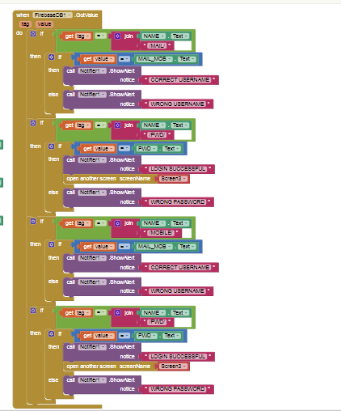

RE-DIRECTING TO OTHER SCREENS:
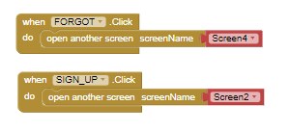

SCREEN-2:(SIGN-UP)

SENDING VERIFICATION MAIL AND SMS:
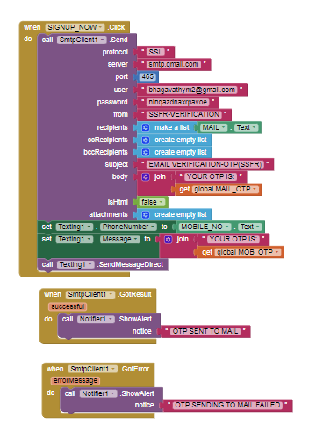

VERIFICATION ALERT AND STORAGE:
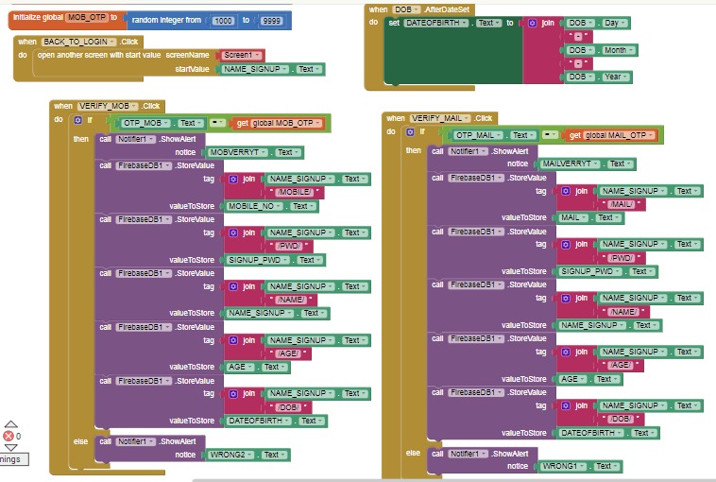

FRONT-END SCREENSHOTS:

SCREEN-1:
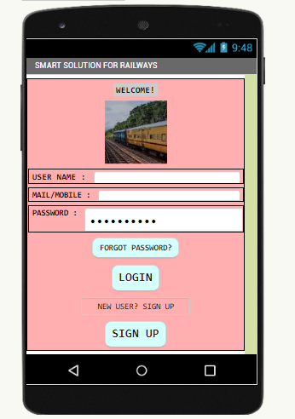

SCREEN-2:
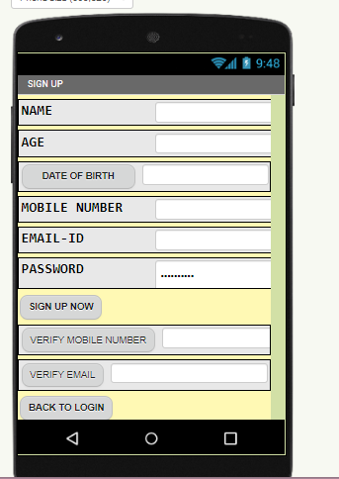

EXTENSIONS USED:

FOR SENDING EMAIL:
